Product specifications
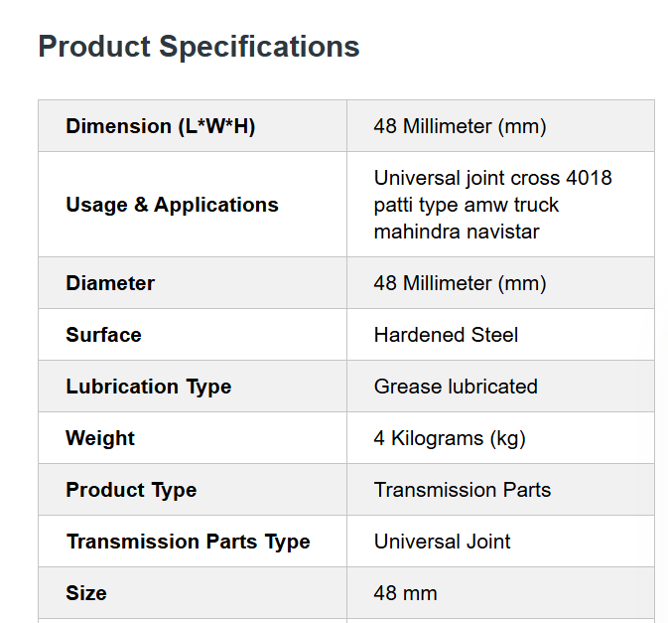

Existing website – audit it and list down the functionalities – also find out

Mobile site should be changed
Add ISO if applicable.
Reviews – on lower priority
Support – search filter
Customer list

